

**University Of Balamand**

**Faculty of Engineering**

**Fuzzy Logic Control**

**Takaji-Sugeno Modeling for Process Control  
Identification of non-linear system   
characterized by non-linear differential equation**

Presented to: Dr. Issam Dagher

Presented by: Kifah DAHER

Date: 25-01-2013

**Introduction:**

Not all physical dynamical systems in real life can be represented by linear differential equations and have a nonlinear nature. At the same time, linear control methods rely on the assumption of small range of operation for the linear model, acquired from linearizing the nonlinear system, to be valid. One way to cope with such difficulty is to develop a nonlinear model composing of a number of sub-models which are simple, understandable, and responsible for respective sub-domains. The fuzzy model proposed by Takagi and Sugeno is described by fuzzy IF-THEN rules (TS rules) which represent input-output relations of a nonlinear system. The main feature of a Takagi-Sugeno fuzzy model is to express the local dynamics of each fuzzy implication (rule) by a linear system model. The overall fuzzy model of the system is achieved by fuzzy "blending" of the linear system models.

**Design:**

The objective of this project is to model a non linear system described by a non linear differential equation. The goal is to derive the TS fuzzy model by the sector nonlinearity approach.

The non linear system to be considered is:

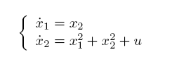

In the following parts T-S fuzzy model is derived using Simulink Fuzzy control toolbox and solving the system usind ODE23 on Matlab is another scenario to verify the results.

Consider $x_{1 }∈\left[0.5,3.5\right] and x_{2}∈[-1,4]$ we make these variables as our fuzzy variables. We construct a model function of state variables in order to solve it such that

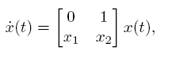

Considering z1 = x1 and z2 = x2 the membership function is to be find:

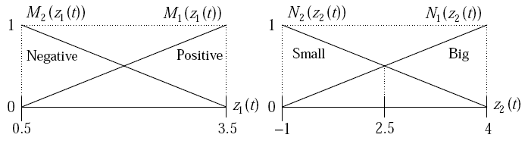

Rules of continuous T-S fuzzy models are of the following forms:

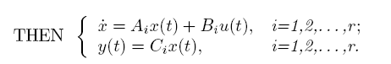

For our model it could be written:

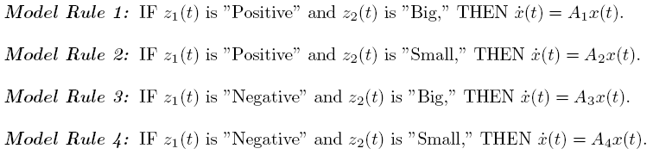

And $\dot{x}$ can be derived by defuzzification process as:



Our T-S Fuzzy rules become:

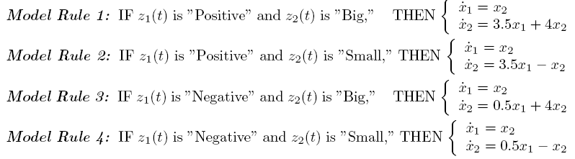

Given the initial values of x1 = z1 = 2.75 and x2 = z2 = 0.25 the membership function give the following:

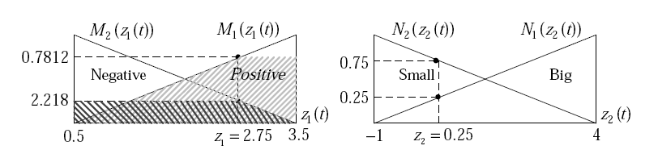

Now the final value of 1 and 2 can be calculated:

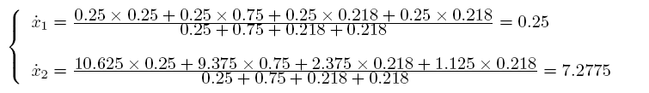

Repeating this Job could be done via the Fuzzy toolbox where we start by entering the membership function input and linear Sugeno output of or system: the figure below show or Fuzzy Takaji Sugeno FIS file:

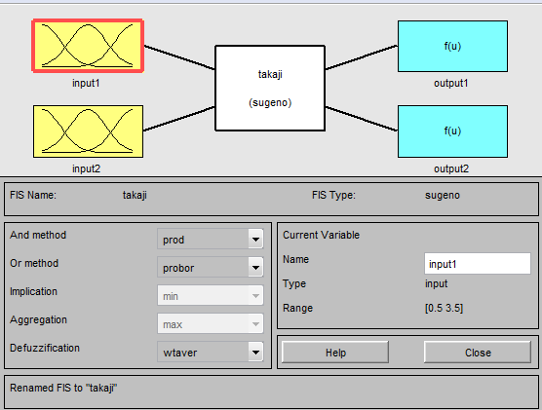

The membership functions are entered as discussed above using triangular membership functions:

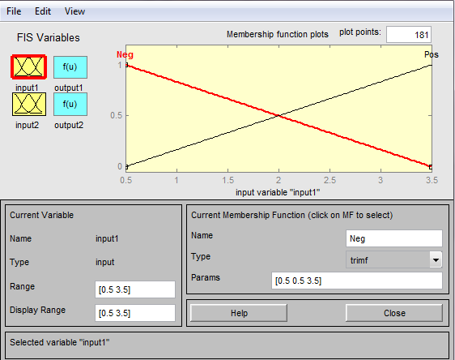

The output is of linear type where we enter the matrices A1, A2, A3 and A4

The figure below show the first output of 1 which is the same of all rules.

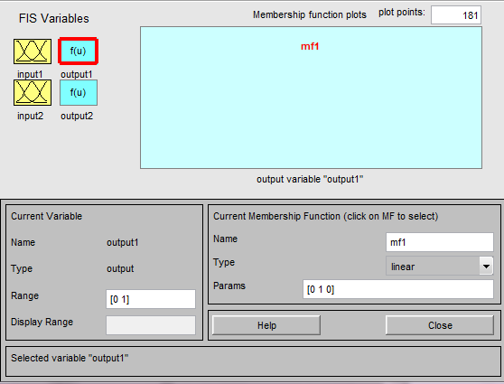

The figure below show the second output of 2 which differ from a rule to another based of A1, A2, A3 and A4.

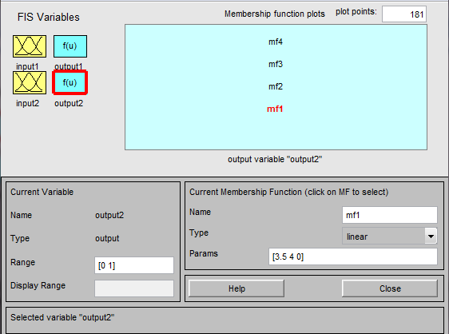

The control surface is shown below and t is linearized for each section

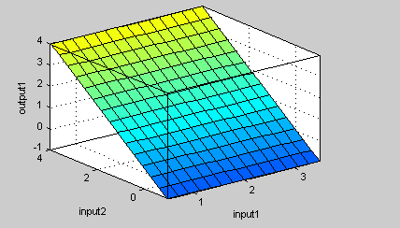

Our Simulink model is simple having two inputs (the initial conditions) and passing through the Fuzzy logic controller new values for x1 and x2 are derived.

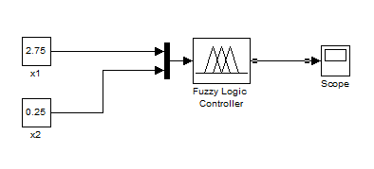

Our output is shown in the scope the cyan line represent the 2 value approximately equal 7.6 whereas the blue one represent the 1 value equal 0.25.

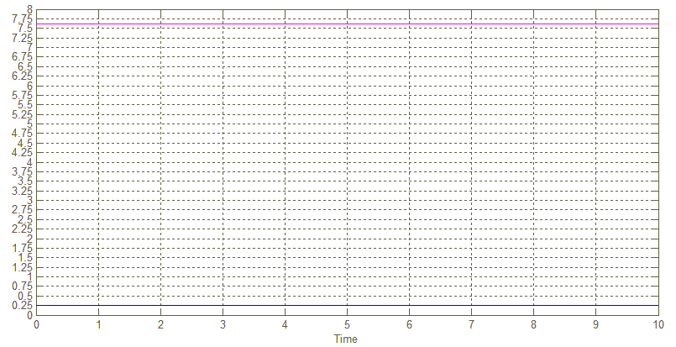

To verify our work I have repeated the model solving process using ODE23 and taking the output at the first iteration. Then both output of Simulink and ODE are compared.

The simple Matlab function code is the following:

function dx = TS(x,t)

x(1)=2.75; % initialize again if any other iteration is executed

x(2)=0.25;

dx(1)=x(2);

dx(2)=x(1)^2 +x(2)^2;

x1_new=dx(1)

x2_new=dx(2)

plot(dx(1),'go','LineWidth',2,'markersize',20);

hold on

plot(dx(2),'ro','LineWidth',2,'markersize',20);

error('program terminated at first iteration!');

dx=dx';

end

calling the ODE23 will give us the results of 1 and 2

ode23('TS',[0 10],[2.75 0.25])

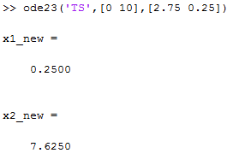

The results from Simulink acquired from the scope output are plotted in a green circle for 1 and red circle 2 whereas the ODE23 results are plotted in blue stars .

plot(ScopeData.signals.values(1,1),'b*','LineWidth',2,'markersize',10)

plot(ScopeData.signals.values(1,2),'b*','LineWidth',2,'markersize',10)



The figure above show the conformity of Simulink results by the ode23 solution. The new values are in the same locations which verify the work done.

**Conclusion:**

The fuzzy model proposed by Takagi and Sugeno is described by fuzzy IF-THEN rules which represents local input-output relations of a nonlinear system. The main feature of a Takagi-Sugeno fuzzy model is to express the local dynamics of each fuzzy implication (rule) by a linear system model. The overall fuzzy model of the system is achieved by fuzzy "blending" of the linear system models. In this project a nonlinear dynamical systems is represented by Takagi- Sugeno fuzzy models to high degree of precision ; the results obtained are the same per manual calculation and they are verified by solving the differential equation by ode23. In fact, it is proved that Takagi-Sugeno fuzzy models are universal approximators of any smooth nonlinear system.